**Occold Foundation Stage and KS1 RE Long Term Plans**

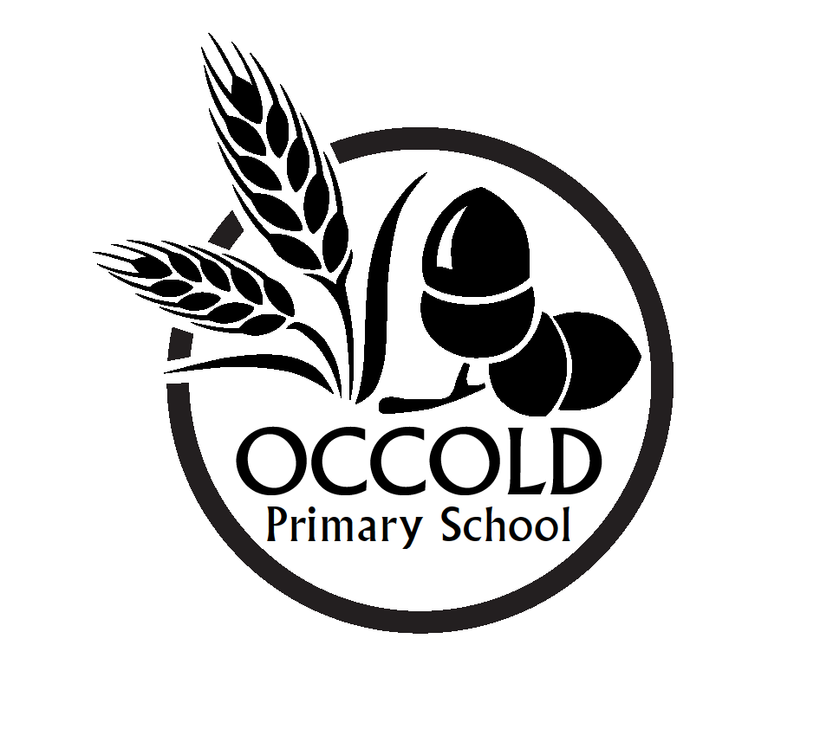

|  |  |
| --- | --- |
| **Key learning expectations Foundation Stage**  Pupils should be taught to | |
| **Learning about religion and belief**   * talk about aspects of some religious stories, including Bible stories and the stories behind Christmas and Easter, e.g. saying what they like about them * recognise simple religious beliefs or teachings e.g. love your neighbour, God is great * identify simple features of religious life and practice in a family context e.g. saying family prayers, naming a baby or celebrating a festival * recognise a number of religious words e.g. religion, pray, church, amen, saint, and in particular, understand the use of the word ‘God’ in a religious context * name the cross as a Christian symbol and recognise some other religious symbols or symbolic clothing e.g. Jewish kippah, Sikh turban * recognise some Christian religious artefacts, including those in cultural as well as religious use e.g. Christmas cards, Easter eggs, hot cross buns. | **Learning from religion and belief**   * recognise aspects of their own experiences and feelings in religious stories and celebrations * recognise there are both similarities and differences between their own lives and those of other children, including those from religious backgrounds * identify what they find interesting or puzzling about religious events * ask questions about puzzling things in religious stories or in the natural world * say what matters or is of value to them and talk about how to care for and respect things that people value * talk about what concerns them about different ways of behaving e.g. being kind and helpful, being unfair or mean. |

|  |  |
| --- | --- |
| **Key learning expectations KS1**  Pupils should be taught to | |
| **Learning about religion and belief**   * explore a range of religious stories and sacred writings, and talk about their meanings * name and explore a range of celebrations, worship and rituals in religion, noting similarities and differences, where appropriate * identify the importance, for some people, of belonging to a religion and recognise the difference this makes to their lives * explore how religious beliefs and ideas can be expressed through the creative and expressive arts and communicate their responses * identify and suggest meanings for religious symbols and begin to use a range of religious words and phrases. | **Learning from religion and belief**   * reflect on and consider religious and spiritual feelings, experiences and concepts, such as worship, wonder, praise, thanks, concern, joy and sadness * ask and respond imaginatively to puzzling questions, communicating their ideas * identify what matters to them and others, including those with religious commitments, and communicate their responses * reflect on how spiritual and moral values relate to their own behaviour particularly those concerned with right and wrong, justice and injustice * recognise that religious teachings and ideas make a difference to individuals, families and the local community. |

**Rabbit Class Cycle A**

|  |  |  |
| --- | --- | --- |
| **Term** | **Learning Theme** | **Focus** |
| Autumn 1 | Christianity | Creation Story |
| Autumn 2 | Celebrations | Christmas and Advent |
| Spring 1 | Religion and the Individual - Islam | Ramadan |
| Spring 2 | Christianity | Easter |
| Summer 1 | Places of Worship | Including places of importance to them |
| Summer 2 | Christianity | Journeys in life |

**Rabbit Class Cycle B**

|  |  |  |
| --- | --- | --- |
| **Term** | **Learning Theme** | **Focus** |
| Autumn 1 | Christianity | Belonging/Baptism/Churches |
| Autumn 2 | Celebrations | Christianity - Christmas and Judaism - Hanukkah |
| Spring 1 | Religion and the individual | Buddhism – Story of Buddha |
| Spring 2 | Stories and Books | Bible – morals in stories |
| Summer 1 | Religious Symbols and signs | All six religions |
| Summer 2 | Christianity | Who is Jesus/God |