
Occold Primary School
Maths Long Term Plan – Reception and year 1

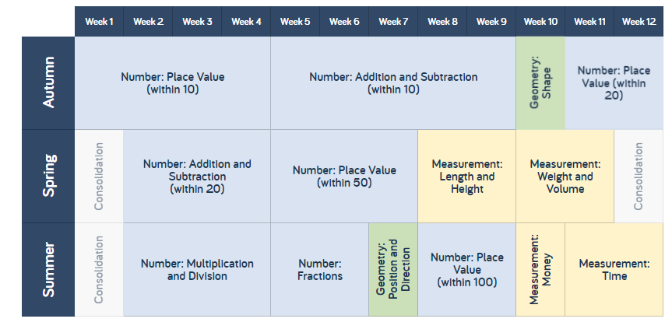

Occold Primary School
Maths Long Term Plan – Year 2

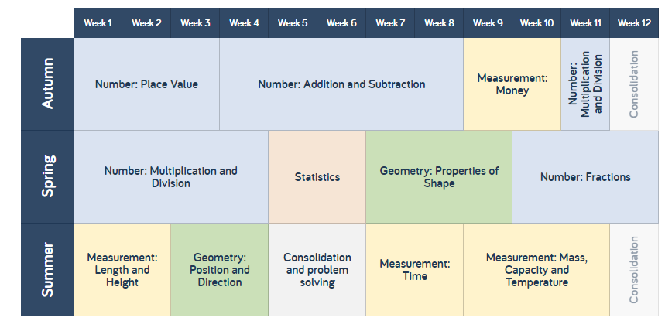

Occold Primary School
Maths Long Term Plan – Year 3 and 4
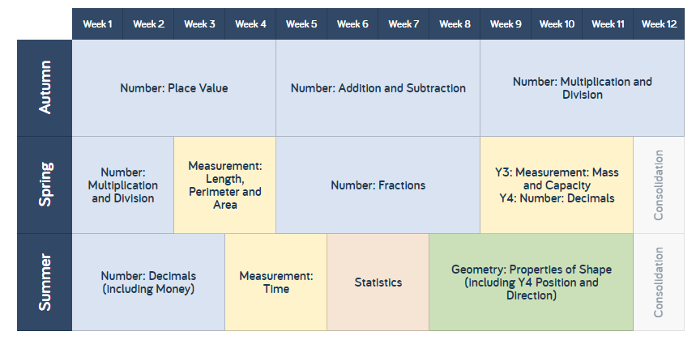

Occold Primary School
Maths Long Term Plan – Year 5 and 6



